**Project Report**

**Title: Sociopedia (Social Media Webapp)**

**Team No. : 145206**

**Team Members**

**Ansh Jindal (22BCE10333)**

**Laskshay Peswani (22BCE10484)**

**Manas Dwivedi (22BCE10855)**

**Samrath Thapar (22BCE10978)**

## 1. INTRODUCTION

### 1.1 Project Overview

In the modern digital age, social media has become a cornerstone of communication, expression, and community-building. *Sociopedia* is a full-stack social media web application designed to facilitate seamless user interaction, content sharing, and community engagement in a user-friendly and intuitive platform. Developed using the MERN (MongoDB, Express.js, React.js, Node.js) stack, Sociopedia provides a dynamic and interactive interface where users can create accounts, share posts, like, comment, and follow other users, thereby creating a connected virtual community.

The application reflects the core features expected of a modern social networking platform while maintaining simplicity, performance, and scalability. The design emphasizes user privacy, efficient content management, and real-time interactions, catering to the growing demand for digital social connectivity in an increasingly online world.

### 1.2 Purpose

The primary purpose of *Sociopedia* is to provide a platform where users can create and share their thoughts, experiences, and multimedia content with their network in a secure and engaging environment. The app aims to:

* Enable users to build their social identity online.
* Promote meaningful interactions through likes, comments, and follows.
* Offer a responsive and aesthetic user experience across devices.
* Serve as a learning project to apply full-stack development skills in a real-world scenario.

Sociopedia is not only a technical achievement but also a step toward understanding user-centered design, application security, and scalable architecture in social media platforms.

### 2. IDEATION PHASE

#### 2.1 Problem Statement

In the current era, while numerous social media platforms exist, most are either overly complex, riddled with ads, or lack user privacy and intuitive design. There is a need for a simple, clean, and engaging platform that prioritizes user experience and enables people to connect, share, and interact without distractions. The challenge lies in building a platform that is both user-friendly and feature-rich, offering core functionalities like posting, liking, commenting, and following, while ensuring scalability, security, and modern UI/UX standards.

#### 2.2 Empathy Map Canvas

To better understand our target users, we created an empathy map canvas:

* **Says**: "I want a clean and easy-to-use social media app." / "I hate unnecessary ads."
* **Thinks**: "Is my data safe?" / "Will I be able to reach more people with my content?"
* **Does**: Frequently checks feeds, likes posts, and follows people of interest.
* **Feels**: Curious to explore, happy when engaging, frustrated with cluttered UI.

This mapping helped us identify the emotional and functional needs of users, shaping the direction of our design.

#### 2.3 Brainstorming

In the brainstorming phase, we explored the must-have features and user expectations from a social media platform. Key points included:

* Clean and responsive user interface
* Secure authentication (login/signup)
* Post creation and feed system
* Like and comment functionalities
* User profile customization
* Follow and unfollow system
* Scalable backend for data management

After several team discussions, we finalized a feature set that was feasible within the project timeline and addressed core user needs.

### 

### 

### 

### 3. REQUIREMENT ANALYSIS

#### 3.1 Customer Journey Map

The user journey in Sociopedia begins from the point of discovery and continues through engagement and retention. The main steps include:

* **Awareness**: User learns about Sociopedia through peers or promotions.
* **Onboarding**: Users sign up and set up their profile.
* **Engagement**: User creates posts, likes, comments, and follows others.
* **Retention**: User returns regularly to interact with content and maintain social connections.
* **Feedback**: User shares feedback to improve platform experience.

This journey helps us identify friction points and optimize the app for better usability.

#### 3.2 Solution Requirement

To deliver the intended user experience, the following requirements were identified:

* **Functional Requirements**:  
  + User authentication (sign up, log in, log out)
  + Post creation, display, and deletion
  + Like, comment, and follow/unfollow features
  + Profile view and editing
* **Non-Functional Requirements**:  
  + Scalability of the backend system
  + Responsive and mobile-friendly UI
  + Secure password handling
  + Fast loading time and low latency

#### 3.3 Data Flow Diagram

The data flow within Sociopedia is structured to ensure efficient information handling. A simplified Level 1 DFD includes:

* **User**: Inputs data (posts, comments, likes) through the UI
* **Frontend (React)**: Sends requests to backend APIs
* **Backend (Node.js + Express)**: Processes requests and applies business logic
* **Database (MongoDB)**: Stores user data, posts, and interactions
* **Frontend**: Receives data and displays it in real-time or on refresh

This flow supports both synchronous and asynchronous operations like commenting or liking posts.

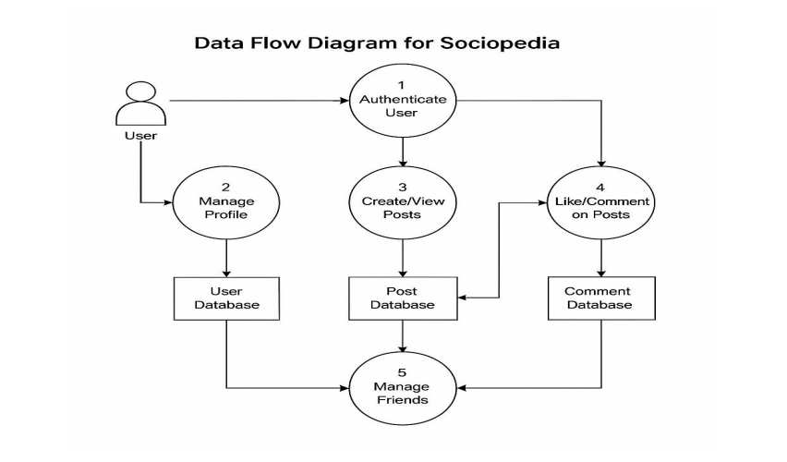

#### 

#### 3.4 Technology Stack

Sociopedia was developed using the MERN stack:

* **MongoDB**: NoSQL database used to store user profiles, posts, comments, and likes.
* **Express.js**: Backend web application framework used to build RESTful APIs.
* **React.js**: Frontend JavaScript library used to build interactive and responsive UI components.
* **Node.js**: JavaScript runtime used to run the backend server and handle API requests.

This stack provides flexibility, real-time updates, and scalability required for modern web applications.

### 4. PROJECT DESIGN

#### 4.1 Problem Solution Fit

The core problem identified was the lack of a clean, ad-free, user-centric social media experience. Most existing platforms either compromise on privacy or overwhelm users with complex interfaces and unwanted content. Sociopedia offers a solution that is minimal, secure, and intuitive, fitting perfectly for users who seek meaningful social interaction in a distraction-free digital space.

Our platform aligns with the problem by incorporating only essential features and emphasizing simplicity, ensuring that users can focus on content and connections without any digital noise.

#### 4.2 Proposed Solution

Sociopedia is designed as a responsive and scalable social media platform where users can:

* Create and manage personal profiles
* Share text and multimedia posts
* Like and comment on posts
* Follow and unfollow other users
* View a personalized feed based on connections

The solution prioritizes speed, accessibility, and ease of use while maintaining data integrity and security across user actions.

#### 4.3 Solution Architecture

The architecture of Sociopedia follows a modular full-stack design pattern:

* **Frontend (React.js)**: Handles the user interface and interaction. Uses Redux for state management and Axios for API calls.
* **Backend (Node.js + Express.js)**: Manages routing, authentication, and business logic. It acts as the intermediary between frontend and database.
* **Database (MongoDB)**: Stores structured user information, posts, comments, likes, and follower relationships.
* **Authentication**: Implemented using JWT (JSON Web Token) for secure user sessions and API protection.

This layered architecture ensures separation of concerns, scalability, and maintainability of the application, making it suitable for future feature additions and performance upgrades.

### 

### 5. PROJECT PLANNING & SCHEDULING

#### 5.1 Project Planning

The development of Sociopedia was planned and executed in multiple iterative phases to ensure timely progress and quality outcomes. The planning process included task allocation, setting milestones, and tracking deliverables using agile methodology.

**Project Timeline:**

* **Week 1**:  
  + Ideation and problem identification
  + Research on existing platforms
  + Finalizing core features
* **Week 2**:  
  + Designing wireframes and UI mockups
  + Setting up the frontend environment (React)
  + Initiating backend setup (Node.js, Express.js)
* **Week 3**:  
  + Building user authentication system
  + Creating APIs for user and post management
  + Frontend development for login, signup, and feed
* **Week 4**:  
  + Integrating backend with frontend
  + Implementing like, comment, and follow functionalities
  + Testing and debugging
* **Week 5**:  
  + Final UI enhancements
  + Deployment and documentation
  + Report and presentation preparation

Task management tools like Trello and GitHub Projects were used for organizing development activities, assigning responsibilities, and ensuring efficient collaboration among team members.

### 6. FUNCTIONAL AND PERFORMANCE TESTING

#### 6.1 Performance Testing

To ensure that Sociopedia delivers a smooth and responsive user experience, performance testing was carried out across various components of the application. The key areas tested include:

* **Page Load Time**:  
   React's component-based architecture and optimized routing ensured fast page transitions and reduced load times. Lazy loading techniques were used for better performance.
* **API Response Time**:  
   Backend APIs were tested using tools like Postman and JMeter to ensure quick data retrieval. Most endpoints responded in under 200ms under normal load.
* **Database Efficiency**:  
   MongoDB queries were optimized with proper indexing to handle read and write operations efficiently, even with growing data.
* **Concurrent Users**:  
   Simulated multiple users interacting with the system simultaneously to check server stability. The app handled concurrent activity (posting, liking, commenting) without crashes or lags.
* **Device Responsiveness**:  
   The UI was tested across various screen sizes and devices (laptops, tablets, smartphones) to ensure consistent functionality and appearance.

Overall, Sociopedia performed well under expected user loads, and any bottlenecks identified during testing were promptly resolved through code optimization and database query tuning.

### 

### 7. RESULTS

#### 7.1 Output Screenshots

Sociopedia was successfully developed with all planned core features integrated and functional. Below are the key output screens that showcase the working of the application:

* **User Authentication Page**:  
   A clean and simple login/signup interface with form validation and JWT-based secure login.

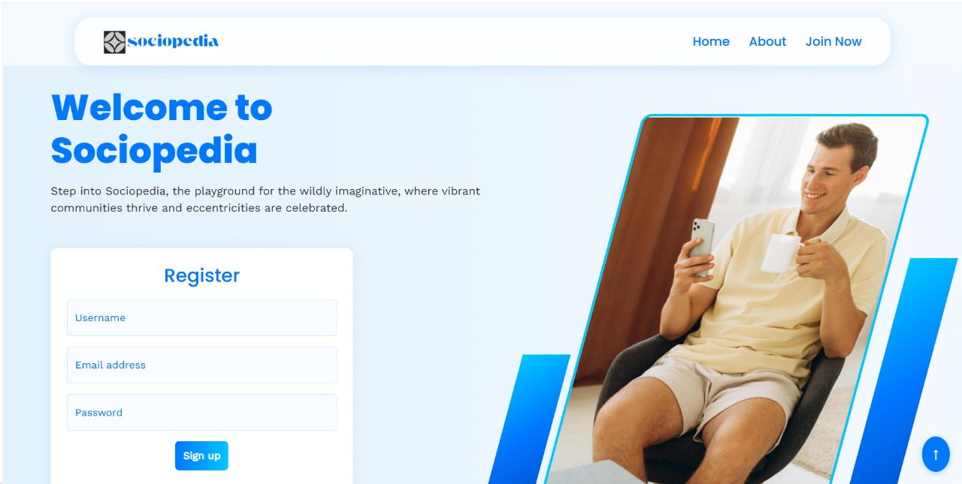

* **Home Feed**:  
   A scrollable feed displaying posts from followed users, with options to like, comment, and view interaction counts.

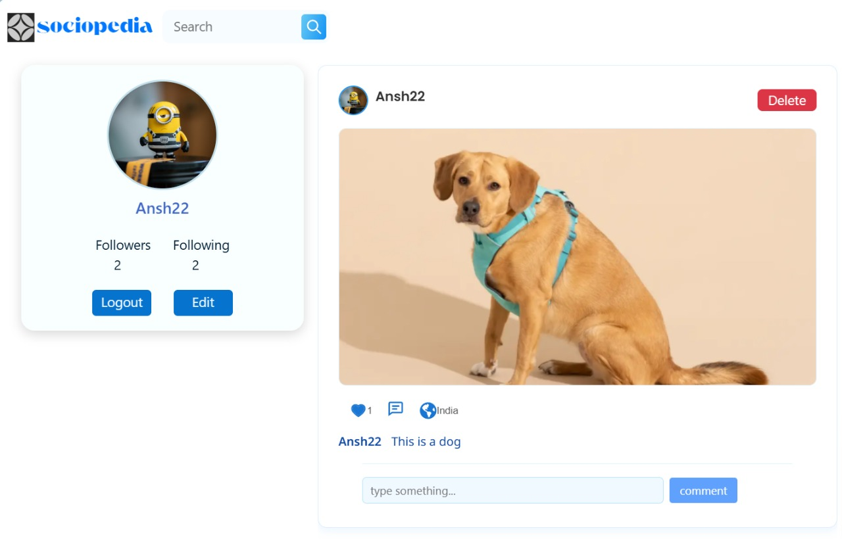

* **Post Creation**:  
   A user-friendly post upload interface allowing users to share text content and multimedia.

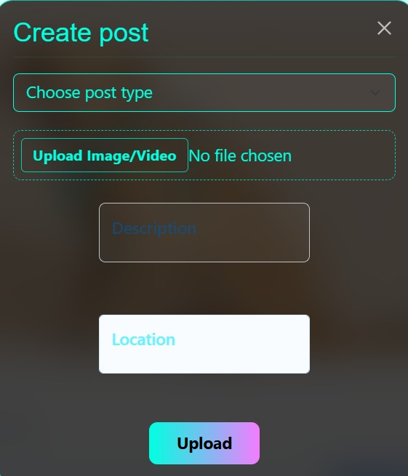

* **User Profile Page**:  
   Displays profile information, list of posts, followers, following, and edit options.

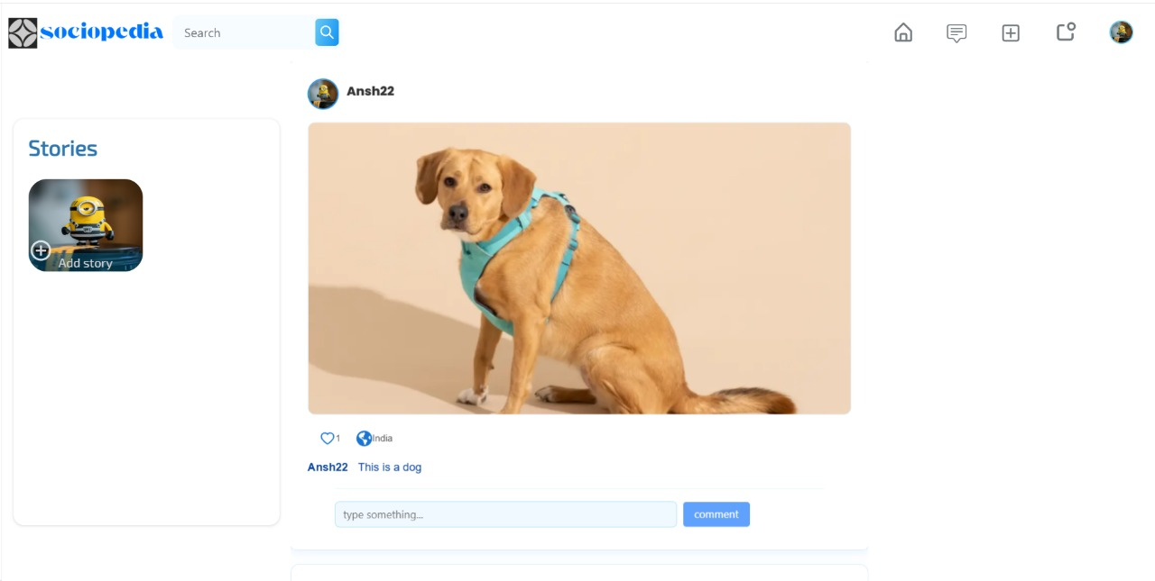

These screenshots validate that the project objectives were successfully met and the platform works as intended. The UI is intuitive, the backend is responsive, and overall, the user experience is smooth and efficient.

### 

### 

### 8. ADVANTAGES & DISADVANTAGES

#### Advantages

* **User-Friendly Interface**:  
   Sociopedia offers a clean, minimal, and intuitive UI that makes it easy for users to navigate and interact with the platform.
* **Real-Time Interaction**:  
   Likes, comments, and post updates are reflected in real-time, enhancing user engagement.
* **Scalable Architecture**:  
   The MERN stack provides a modular and scalable foundation, allowing future expansion with ease.
* **Privacy-Focused**:  
   Secure authentication and minimal data collection ensure user privacy is respected.
* **Responsive Design**:  
   The application works seamlessly across desktops, tablets, and smartphones.
* **Open for Feature Integration**:  
   New features such as messaging, notifications, and stories can be added without major architectural changes.

#### Disadvantages

* **Limited Features in Initial Version**:  
   The MVP focuses only on basic features. Advanced functionalities like messaging, video uploads, and analytics are not yet available.
* **No Offline Mode**:  
   The app requires an active internet connection for usage and does not support offline access.
* **Initial Load Time on Slow Networks**:  
   Due to media-heavy content, the initial load may be slightly slower on poor network connections.
* **No AI-Driven Recommendations**:  
   Feed suggestions are currently basic and do not involve personalized algorithms or machine learning.

### 9. CONCLUSION

Sociopedia successfully demonstrates how a modern, user-centric social media platform can be built using the MERN stack. From initial ideation to final deployment, the project followed a structured development approach focusing on usability, performance, and scalability.

The application enables users to connect, share, and interact in a clean and secure environment. With essential features like posting, liking, commenting, and following users, Sociopedia delivers a smooth and engaging experience. The real-time data flow and responsive UI ensure that users enjoy seamless interaction across devices.

Throughout the development journey, several challenges were tackled — from ensuring backend efficiency to optimizing frontend performance — resulting in a well-rounded and functioning MVP. Sociopedia lays a strong foundation for future growth and advanced feature integration.

This project not only strengthened technical and collaborative skills but also provided hands-on experience with full-stack development, project planning, and problem-solving in a real-world context.

### 10. FUTURE SCOPE

Sociopedia, while currently operating as a basic social media platform, holds great potential for growth and feature enhancement. Future development plans include:

* **Direct Messaging System**:  
   Integrating a real-time chat feature using WebSockets or Firebase to enable private user communication.
* **AI-Powered Feed Curation**:  
   Implementing machine learning algorithms to personalize user feeds based on interests, engagement history, and activity patterns.
* **Story Sharing Feature**:  
   Allowing users to post short-lived content (stories) that disappear after 24 hours, enhancing user interaction.
* **Push Notifications**:  
   Adding real-time notifications for likes, comments, new followers, and post interactions to improve user engagement.
* **Dark Mode & Theme Customization**:  
   Providing users the option to personalize the look and feel of the app for a better visual experience.
* **Analytics Dashboard**:  
   Creating a user analytics panel to show profile views, post reach, and engagement statistics.
* **Multilingual Support**:  
   Supporting multiple languages to expand the app’s accessibility to users across different regions.
* **Enhanced Security Measures**:  
   Incorporating two-factor authentication and advanced encryption for enhanced data privacy.

With these future upgrades, Sociopedia aims to evolve into a more dynamic, feature-rich, and inclusive platform while continuing to provide a secure and user-friendly social media experience.

### 11. APPENDIX

#### Source Code

The source code for Sociopedia is available on GitHub. It contains the full implementation of both the frontend and backend, including the following directories:

* **Frontend**: Contains the React.js application, components, state management using Redux, and API interaction using Axios.
* **Backend**: Includes the Node.js and Express.js setup, routes, controllers, and middleware for handling user authentication, posts, and comments.
* **Database**: MongoDB schemas for user profiles, posts, comments, and interactions.